Pan-AfriKan hurricane Relief Effort
We don’t have to wait on the Red Cross or the Government. We can help our own!

Hurricane Katrina and Rita displaced thousands of Black Families in Louisiana, Mississippi, Alabama, and Texas. These Families are now without food, shelter, clothes, medical care, homes, schools and jobs. Many have also lost their loves ones. Many will struggle all year long.
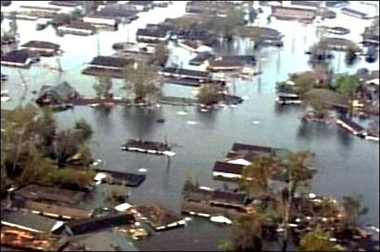
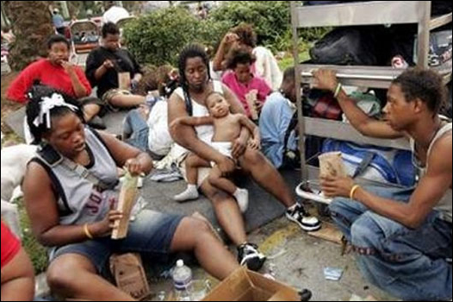

We also watched helplessly as our government failed to help evacuate endangered cities, contractors collected hundreds of millions of dollars to do nothing and community leaders traded insults, while we suffered!

never again!

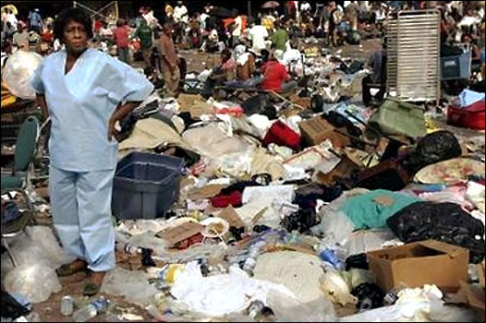
Support Black community organizations that can provide DIRECT social services like housing placement, job referrals, new school placements, medical care and emergency assistance to Black Hurricane Victims.

LOG ON TO LEARN MORE »
LEARN MORE ABOUT THIS ACTION ALERT, THE COMMUNITY PARTNERS AND MAKE DONATIONS:
WWW.ASSATASHAKUR.ORG/1005.HTM

