Protest Police Brutality


“What is the world coming to when Civil Rights Leaders are victims of police brutality on Black College campuses?”

Justice for Mukasa Dada (Willie Ricks)

Civil RIghts Icon
WHAT YOU SHOULD DO NOW
- Call Morehouse Police: 1-404-215-2666
- Call Morehouse President, Dr. Massey: 1-404-215-2645
- Call Morehouse Public Relations: 1-404-614-3788
- Fax Letters to Morehouse #1: 1-404-659-6536
Fax Letters to Morehouse #2: 1-404-215-2729
- Mail Letters To Dr. Walter E. Massey
Morehouse College, 830 Westview Drive, S.W., Atlanta, GA 30314

A Badge doesn’t Make it right!
Protest Police Brutality!

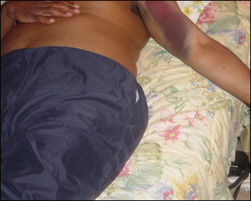

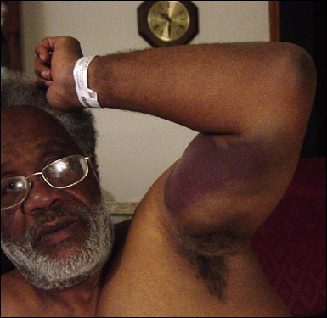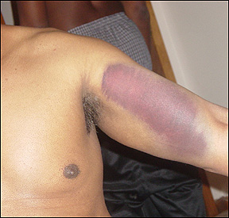

Get educated, get organized , get involved!
Assata Speaks! / Talking Drum Collective

Get More Details:
www.assatashakur.org/1205.htm

Morehouse College Police Beat Up Civil Rights Leader!
Morehouse police beat up Civil Rights Leader and Elder, Mukasa Dada formerly known as Willie Ricks of Student Nonviolent Coordinating Committee (SNCC), Thursday, November 10, 2005 on the Morehouse campus in an act of over zealous rage.
As a Field Secretary for SNCC, activist and freedom fighter for Black people in general, we feel this attack by Morehouse Police is dishonorable, appallingly contradictory, and a slap in the face to all Black Leadership past, present, and future. Mukasa Dada’s history in the civil rights movement, Black power movement, and all Black progressive movements is impeccable.

